Packet Tracer - Propagating a Default Route in OSPFv2

1. Topology

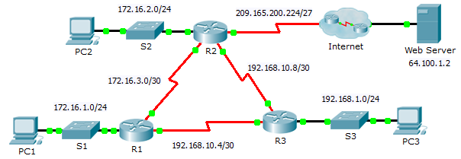

1. Addressing Table

|  |  |  |  |  |
| --- | --- | --- | --- | --- |
| Device | Interface | IPv4 Address | Subnet Mask | Default Gateway |
| R1 | G0/0 | 172.16.1.1 | 255.255.255.0 | N/A |
| S0/0/0 | 172.16.3.1 | 255.255.255.252 | N/A |
| S0/0/1 | 192.168.10.5 | 255.255.255.252 | N/A |
| R2 | G0/0 | 172.16.2.1 | 255.255.255.0 | N/A |
| S0/0/0 | 172.16.3.2 | 255.255.255.252 | N/A |
| S0/0/1 | 192.168.10.9 | 255.255.255.252 | N/A |
| S0/1/0 | 209.165.200.225 | 255.255.255.224 | N/A |
| R3 | G0/0 | 192.168.1.1 | 255.255.255.0 | N/A |
| S0/0/0 | 192.168.10.6 | 255.255.255.252 | N/A |
| S0/0/1 | 192.168.10.10 | 255.255.255.252 | N/A |
| PC1 | NIC | 172.16.1.2 | 255.255.255.0 | 172.16.1.1 |
| PC2 | NIC | 172.16.2.2 | 255.255.255.0 | 172.16.2.1 |
| PC3 | NIC | 192.168.1.2 | 255.255.255.0 | 192.168.1.1 |

1. Objectives

Part 1: Propagate a Default Route

Part 2: Verify Connectivity

Background

In this activity, you will configure an IPv4 default route to the Internet and propagate that default route to other OSPF routers. You will then verify the default route is in downstream routing tables and that hosts can now access a web server on the Internet.

1. Propagate a Default Route
   1. Configure a default route on R2.

Configure **R2** with a directly attached default route to the Internet.

R2(config)# **ip route 0.0.0.0 0.0.0.0 Serial0/1/0**

* 1. Propagate the route in OSPF.

Configure OSPF to propagate the default route in OSPF routing updates.

R2(config-router)# **default-information originate**

* 1. Examine the routing tables on R1 and R3.

Examine the routing tables of **R1** and **R3** to verify that the route has been propagated.

R1> **show ip route**

<output omitted>

O*E2 0.0.0.0/0 [110/1] via 172.16.3.2, 00:00:08, Serial0/0/0

!-------------------

R3> **show ip route**

<output omitted>

O*E2 0.0.0.0/0 [110/1] via 192.168.10.9, 00:08:15, Serial0/0/1

1. Verify Connectivity

Verify that **PC1**, **PC2**,and **PC3** can ping the web server.